**15.4. Checking for Required Fields Overview**

**Required Fields**:

Here we are working with a form. In this form we have “First Name” and “Last Name”. Here last name is required. Without write last name if user press the submit button it will display a message “is required”.

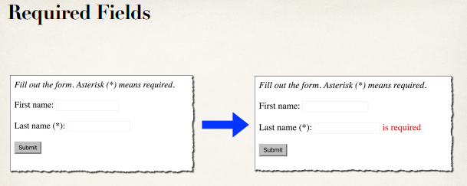

**Working process**:

1. User insert data and hit submit button.
2. Data pass over a customer object to our customer controller
3. In customer controller we actually perform the validation
4. If the validation is successful, we’ll send them to the confirmation page
5. If the validation fails, we’ll actually send them back to the customer form to fix it and resubmit again.

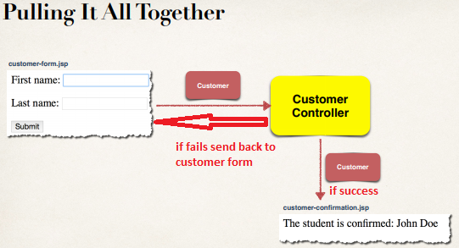

**Development Process**:

1. Add validation rule to Customer class
2. Display error messages on HTML form
3. Perform validation in the Controller class
4. Update confirmation page

**Step 1: Add validation rule to Customer class**:

**import** javax.validation.constraints.NotNull;

**import** javax.validation.constraints.Size;

**public** **class** Customer {

**private** String firstName;

@NotNull(message = "is required")

@Size(min = 1)

**private** String lastName;

// getter-setter methods

}

**Step 2: Display error message on HTML form**:

<%@ taglib prefix=*"form"* uri=*"http://www.springframework.org/tags/form"*%>

<html>

<head>

<meta charset=*"ISO-8859-1"*>

<title>Customer Registration Form</title>

<style type=*"text/css"*>

*.error* {

color: *red*;

}

</style>

</head>

<body>

<i><b>Fill out the form. Asterisk (*) means required</b></i>

<br></br>

<form:form action=*"processForm"* modelAttribute=*"customer"*>

First Name: <form:input path=*"firstName"* />

<br></br>

Last Name (*): <form:input path=*"lasttName"* />

<form:errors path=*"lastName"* cssClass=*"error"* />

<br></br>

<input type=*"submit"* value=*"Submit"* />

</form:form>

</body>

</html>

**Diagram**:

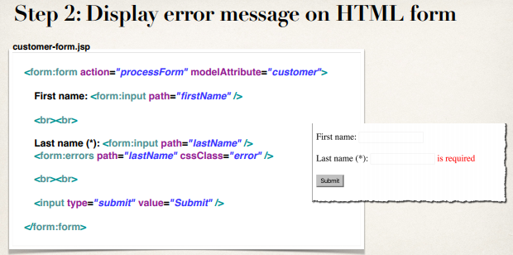

**Step 3: Perform validation in Controller class**:

**package** com.ruhul.odduu.springmvc;

**import** javax.validation.Valid;

**import** org.springframework.stereotype.Controller;

**import** org.springframework.ui.Model;

**import** org.springframework.validation.BindingResult;

**import** org.springframework.web.bind.annotation.ModelAttribute;

**import** org.springframework.web.bind.annotation.RequestMapping;

@Controller

@RequestMapping("/customer")

**public** **class** CustomerController {

@RequestMapping("/showForm")

**public** String showForm(Model theModel) {

theModel.addAttribute("customer", **new** Customer());

**return** "customer-form";

}

@RequestMapping("/processForm")

**public** String processForm(@Valid @ModelAttribute("customer") Customer theCustomer, BindingResult theBindingResult) {

**if** (theBindingResult.hasErrors()) {

**return** "customer-form";

} **else** {

**return** "customer-confirmation";

}

}

}

**Diagram**:

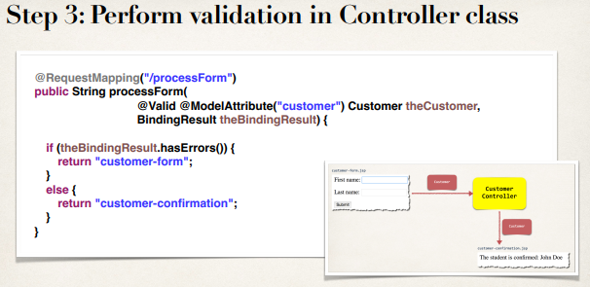

**Step 4: Update confirmation page**:

<%@taglib uri=*"http://java.sun.com/jstl/core"* prefix=*"c"*%>

<!DOCTYPE html>

<html>

<head>

<meta charset=*"ISO-8859-1"*>

<title>Customer Confirmation</title>

</head>

<body>

The customer is confirmed: ${customer.firstName} ${customer.lastName}

</body>

</html>

15.4. Checking for Required Fields Overview